6/10/2021

**DCCN FINAL PROJECT**

**SPORT COMPLEX MANAGEMENT SYSTEM**

**CLASS:** BSE 5B

**SUBJECT:** DATA COMMUNICATIONS AND COMPUTER NETWORKS

**SUBMITTED BY:**

Hafiz. M. Usman Hameed (SP19-BSE-051)

Muhammd Moin (SP19-BSE-078)

Romana Aijaz (SP19-BSE-096)

**SUBMITTED TO:**

Dr. M. WAQAR

# **Use of Sports Complex Management System:**

Sports Complex Management is Ideally Design for the Ease of Sports Complex of the Comsats University Islamabad. The main Objective of this Project is to Shift all the Data into Software Form Rather than Old Hand Written From. As there are Many Drawbacks of that Old System, We have tried to overcome those Drawbacks and to Shift the Entire Records on to This Software For the Ease of Everyone

# **Modules:**

## **Grounds:**

Grounds Information will be entered into the Software (e.g. Ground Name, slots and Price) and Admins will be able to:

* Add more Grounds Records
* View more Grounds Records
* Edit more Grounds Records
* Search more Grounds Records
* Delete more Grounds Records

## **Members:**

Member’s data will be entered into the Software, Member’s ID, name, Age and City Will be required to be added into the List

* Member would be able to Add Their Data
* Member would be able to View Their Data
* Member would be able to Edit Their Data
* Member would be able to Search Their Data
* Member would be able to Delete Their Data

## **Sales:**

Existing Members Would be able to book Slots by Giving their own Member Id, Ground Id, Then The Members Would be asked about Booking of slots, Upon Confirmation Bill will be Showed to the Members

* Would enable to book ground
* Would enable to view all ground booking

# **Initial proposed concept of this Project:**

# **What is missing in the delivered part?**

* No parallel two way connection
* One-way file transfer only achieved (server -> client)

# **Screenshots:**

* Opening view page

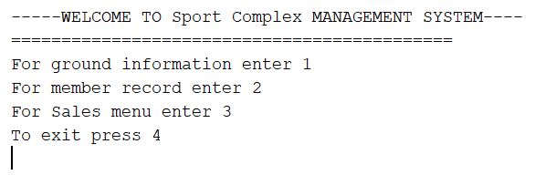

* Ground information section:

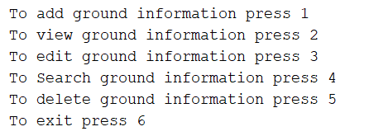

* To add Ground information

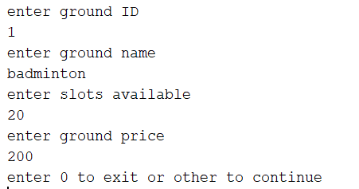

* To view Ground information

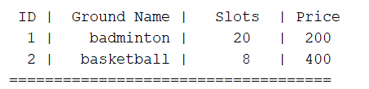

* To edit Ground information

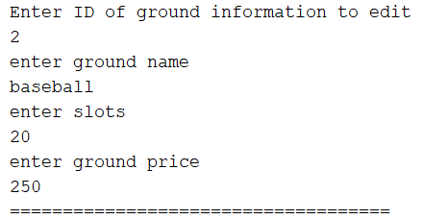

* To search Ground information

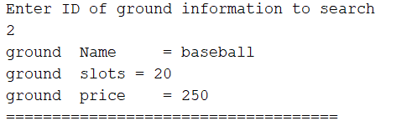

* To add Member information

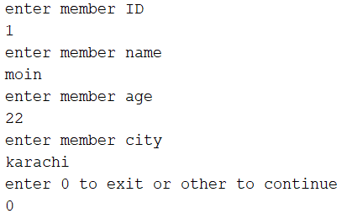

* To view Member information

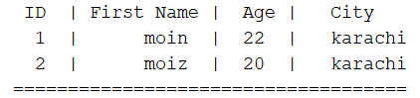

* To edit Member information

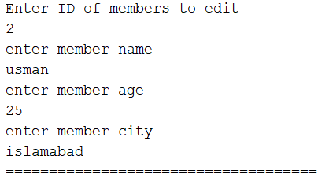

* To search Member information

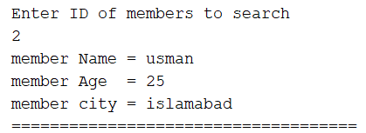

* Booking section

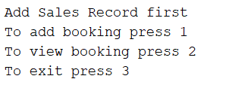

* To Book Ground

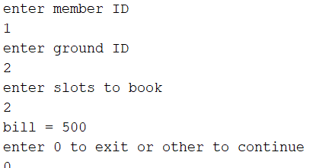

* To view all Booking

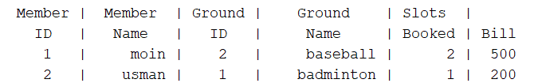

GUI Output Screenshots:

